Week Beginning__11/01/21____ Year _2__
Monday | Tuesday | Wednesday | Thursday | Friday
Maths  Counting on using a numberline  https://classroom.thenational.academy/lessons/to-add-by-counting-on-using-a-number-line-ccukct | Maths  Subtracting using a numberline  https://classroom.thenational.academy/lessons/to-subtract-by-counting-back-using-a-number-line-cgr36d | Maths  Number bonds  e.g. 12 + 18 and 17 + 13 | Maths  adding a one digit number to a teen number  https://classroom.thenational.academy/lessons/to-add-a-1-digit-number-to-a-teens-number-using-a-known-fact-69gkat | Maths  Compensating to subtract - if one of the numbers is near a multiple of 10
English  Describing Sea Creatures  *Write into your book | English  Under the Sea - Setting Description – Senses.  Watch the video - What would you see under the sea?  Describe the setting using the senses.  What would you see, hear, smell, taste, touch.  Begin to describe setting/scenery/animals using 2A sentences(2 adjectives separated by a comma) – include the animals from previous lesson e.g. an orange, spiky sea cucumber.  *Write into your book | English  Similes  *Complete the sentences and write into your book | English  Edit and improve the setting description.  Check for:  - Capital Letters  - Full stops  - Commas  - Spelling mistakes  *Write into your book  Please see following pages for reference. | English  Big Write – Underwater Setting Descriptions  Have a go at writing your own setting descriptions for under water – Can you draw a picture for it as well.  *Write into your book
RE –  Jairus’ Daughter.  Video for reference - https://www.youtube.com/watch?v=dUjrJWqooLE | Geography – Antarctica  https://classroom.thenational.academy/lessons/what-is-antarctica-like-65j3ge | Science – Plants  https://classroom.thenational.academy/lessons/how-do-i-plant-a-bean-cgwp6e | Music – pitch  https://classroom.thenational.academy/lessons/following-the-pitch-6nk34t | PSHE –  Feeling Better

ENGLISH TASK
** Some children may need support reading **

Have a go at re-writing this into your book.
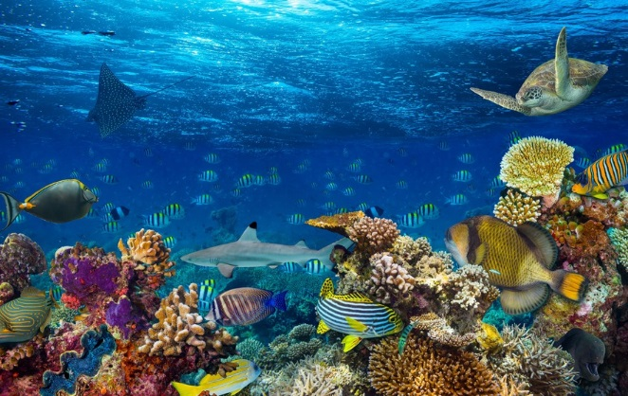
Can you add full stops and capital letters?

i felt the calm, warm water splashing all around me i opened my eyes are saw the soft, fluffy clouds floating above me turquoise, blue water was all around me in the distance i could see green, mossy seaweed
i started to swim underwater to see some huge, bright sea creatures swimming alongside tiny, wide-eyed fish there were as many fish as there were stars in the sky!
the sunlight shone straight to the grey, rocky bottom i saw a hole, as dark as the night sky i wanted to go through and have a look at the many wonders under the sea
as i was swimming, i pushed through the soft, emerald swaying seaweed, i came face to face with a spiky, silver starfish when i looked around i saw a magical rain forest but underwater under me i could see pink and orange coral which looked like mini tree reaching up to the salty, blue sky
i saw a glowing light so i decided to swim quickly towards it, the light was so bright my eyes couldn’t move from it, i knew that it was time to return back to my boat and sail away with my best friend

ENGLISH EXTENSION TASK

Can you make this Under Water Setting Description better?
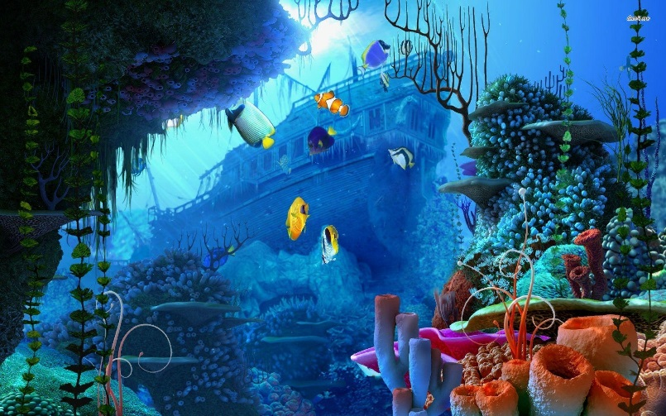
Think about using:
- Full stops.
- Capital letters
- Your senses (See, Taste, Touch, Smell, Hear)
- Similies
- Adjectives
- Commas
- Verbs
- Adverbs

i saw water. i opened my eyes and saw clouds. i felt the water around me. i started to swim and swam into big fish. i saw next to small sea creatures.
there were lots of fish.
the sun shone through. i saw a hole. i touched seaweed. I drank water. i saw a starfish. i felt the underwater forest.i saw coral. I heard dolphins. i swam to the top. i had fun.

