Year 4
Monday | Tuesday | Wednesday | Thursday | Friday
Maths  Talk through the worksheet attached. Look at the numbers at each end of the numberline and discuss what possible numbers could be between them. Think about what would be the halfway point and then halfway between those points. Then complete the worksheet. | Maths  Watch through the following lesson on this link-  To recognise, identify and describe unit fractions (thenational.academy)  Complete the following worksheet- | Maths  Make the below picture bigger and talk through the numerator and denominator.  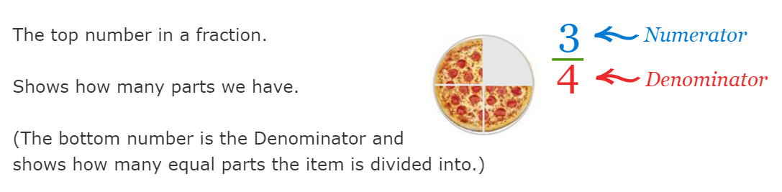  Talk to the children about finding fractions of objects and that we would divide them into the denominator amount of the fraction, then count how many in the number of groups instructed by the numerator. Eg 2/3 of 24 objects is 24 ÷ 3 = 8 x 2 = 16, so 2/3 of 24 = 16.  Complete the following worksheet- | Maths  Watch through the following lesson on this link-  To find unit fractions of a given quantity (thenational.academy)  Remember if finding non-unit fractions you multiply the unit fraction by the numerator. Complete the following worksheet- | Maths  Talk to the children about the language used in the word problems. Eg what is it asking us to do? Then ask them how we might work this out. Find the fractions then answer in words.
English  Using conjunctions  TASK  Create a spider diagram populated with a range of conjunctions.  Using the sentences created from previous lesson, improve by inserting conjunctions to add more information. | English  Making inferences based upon character’s feelings.  TASK  Using the powerpoint provided, explore the rest of the text ‘The Whale’.  After completion of exploring the narrative, children will engage with the following questions.  - How do you think the children felt after reading the newspaper article?  - Give three adjectives to describe the journey the two young children went on.  - How do you think the children felt after discovering that it was their own grandparents who first sighted the Great Spotted Whale fifty years ago.  They should then track the feelings of the two young children in the book throughout in chronological order. Children should use emotive language such as intelligent and brave (positive) and lazy and unhappy (negative).  This can be represented in the form of a timeline, picking key parts of the book. | English  Description of main character/ setting.  TASK  Using an image of either the characters in the book or the setting (see powerpoint), children will annotate using adjectives, similes or any other observations made.  Children should then write a setting or a character description using and applying earlier learning on possessive pronouns and conjunctions to describe attributes and give additional information. | English  Planning a narrative  TASK  Children to plan and draft ideas for their narrative. Children to create a story board consisting of 6 images and brief descriptions under each. Can the children retell the narrative in their own words?  Children should consider the feelings of the characters throughout. | English  Writing a narrative  TASK  Children will write their own narrative, retelling in their own words, the story of ‘The Whale’.  They should include a detailed description of a setting and of the characters, using possessive and personal pronouns. They should also include conjunctions to add further information.  Children should aim to include similes and other figurative devices to ensure rich description.
PE  To know the simple nutritional values of certain food groups.  TASK  Children to identify the different food groups and the importance of each group.  Children should research and have a basic understanding of what the different food groups do to our bodies when/ when not staying active. Children should also understand why/what food is needed by the body. | RE  Jesus, the Teacher  TASK  Recall ‘The Presentation of Jesus in the Temple’.  Why is the feast of the Presentation of the Lord important for us? Think about the words of Simeon.  Draw a large, lighted candle in the middle of your page. Write thoughts for Mary, Joseph, Anna and Simeon and put them around your candle. | History  Read through the attached photo of pages 20 and 21-  Then work through the following worksheet- | Science  Work through the following lesson-  What is sound? (thenational.academy)  When you have finished this write up a paragraph explaining how sound is made. | Art  Romanesque Art Period  TASK  Children to research (with permission from an adult) and create a poster explaining the key features of the Romanesque Art Period. Think about:  - Key artists  - Style of art  Examples of art

