Our Lady and St Edwards Knowledge Organiser | Year 5 - Art | Spring | Ancient Greece
Key Facts |  | Key Vocabulary
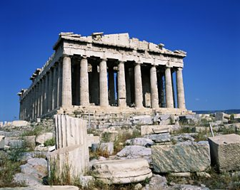  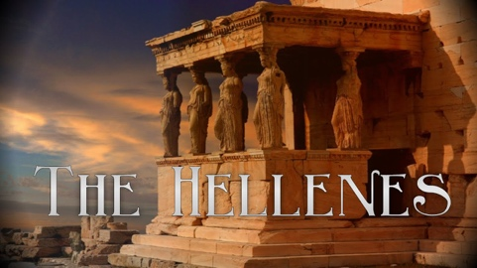  About 2,500 years ago, Greece was one of the most important places in the ancient world. The Greeks were great thinkers, warriors, writers, actors, athletes, artists, architects and politicians. The Greeks called themselves Hellenes.  The Parthenon temple was built for the Greek goddess Athena. It sits on top of a hill called the Acropolis and looks out over the city of Athens. |  | - Hellenes – what the Greeks called themselves.  - Parthenon – a temple was built for the Greek goddess Athena  - Acropolis – a hill in Greece that the Parthenon sits on top of.  - Sculpture - the art of making two- or three-dimensional representative or abstract forms, especially by carving stone or wood or by casting metal or plaster.  - Architect - a person who designs buildings and supervises their construction.  - Ceramics: a term given to any artwork produced using clay.  - Clay: Moist sticky earth. Liquid clay is called slip.  - Firing: Applying heat to harden clay in a large oven called a kiln.
Key Questions |  | Books, internet sites and places to visit
- What is an architect?  - What are the different styles of columns did the Greeks create?  - What materials did the Greeks us to create the Parthenon?  - What tools did the Greeks use to create the Parthenon? |  | https://www.bbc.co.uk/bitesize/topics/z87tn39/articles/zxytpv4  https://www.ducksters.com/history/ancient_greece/architecture.php

