Our Lady and St Edwards Knowledge Organiser | Year 2 - Art | Spring | Artist Study
Information about the Artist |  | Key Vocabulary
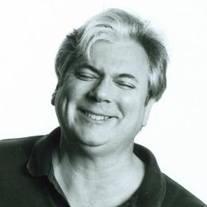  Name: Peter Thorpe  Life: 9th November 1957 (63 years old)  Country of Birth: Oregon, USA  Style/ Focus: Space  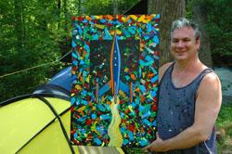  Period: Modern Art  Media: Painting |  | - Modern Art - art of a style that has been created between the late 19th and the late 20th centuries.  - Composition - is the placement of the visual elements, such as figures, trees, and so on in a piece of artwork  - Space Art - is a genre of modern artistic expression that strives to show the wonders of the Universe and Space.  - Canvas - a painting made on a piece of cloth stretched on a frame.  - Abstract - is art that does not attempt to represent an accurate visual reality but instead use shapes, colours, forms and marks.  - Tints- adding black to colours  - Tones- lightness or darkness of a colour  - Strokes – how the paintbrush is used
Some Key Questions: |  | Books, internet sites and places to visit
- What is Space Art?  - What are the elements of art?  - What are the primary colours used in his artwork?  - What are the secondary colours used in his artwork?  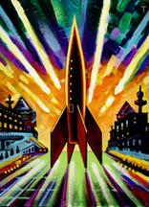  - What can you see in Peter Thorpe’s artwork that is linked to Space?  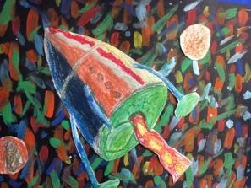  - Is it easier to paint on a canvas or paper? |  | http://peterthorpe.net/rockets  http://peterthorpe.net/bio.html  https://www.feedingstickfigures.com/post/peter-thorpe-inspired-space-art  