Year 4
Monday | Tuesday | Wednesday | Thursday | Friday
Science  Drawing and labelling an electric circuit  What are circuit diagrams? (thenational.academy)  Draw your own Electric circuit, including 2 batteries, one light bulb and a switch. | Maths  Recall known facts-complete tasks on the link  Recalling multiplication and division facts (thenational.academy) | Maths  Know that multiplication and division are inverse operations  Understanding that multiplication and division are inverse operations (thenational.academy) | Maths  Divide 3 digit numbers by 1 digit using the pictoral method shown below (taken from the school’s calculation policy for Year 4)  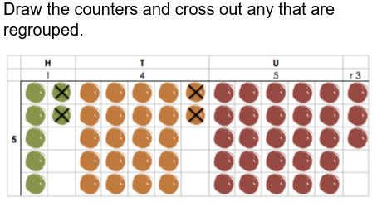 | Maths  Divide 3 digit numbers by 1 digit using the expanded short method shown below (taken from the school’s calculation policy for Year 4)  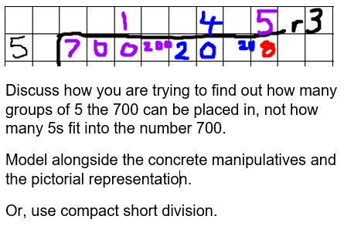
PE  Health and Fitness- To understand why their body temperature changes during exercise.  TASK  Children to create a poster, explaining why their body changes temperature during exercise. Can children discuss and compare the differences of how they feel during and after different types of exercise? | English  Can we use prefixes to change meaning- ‘il’, ‘im’, and ‘in’?  TASK  Children to create a list of words using the different prefixes (im, in, il). Can they define each word and use it in a sentence? Can they discuss how using the specific prefix, changes the meaning of the word? For example, ‘legalillegal’ | English  Using brackets, dashes or commas to indicate parenthesis.  TASK  Children to explore when to use brackets, dashes and commas. They are to then explore the three activities, showing when to indicate parenthesis.  Parenthesis | English  Research- Explanation Texts  TASK  Use the internet to research areas of discussion for their explanation text. Children are to focus on the topic of natural disasters and aim to answer the question ‘How do things happen?’ For example, ‘how do earthquakes happen? How is igneous rock formed?’ | English  Research- Explanation Texts (continuation)  TASK  Use the internet to research areas of discussion for their explanation text. Children are to focus on the topic of natural disasters and aim to answer the question ‘How do things happen?’ For example, ‘how do earthquakes happen? How is igneous rock formed?’
DT  From the design you have made for your Volcano, consider what materials you might use to make your model waterproof. Why would you use these materials? | RE  TASK  Children to plan a collective worship. They will need to include the following:  We gather- a song, a prayer etc  We listen- a Bible reading  We respond- prayer, reflection, singing etc.  Going forth- Prayer, big question, song etc. | Geography  To know the effects of a volcanic eruption on the environment.  To know the effects on people from a volcanic eruption.  TASK  Children to think about the positives and negatives to living besides a volcano.  Children to decide whether they would take the risk of living near. Why/ Why not?  Explore the site of Montserrat (before and after the eruption). Children to draw similarities and fiferences between the two and then write a short description describing the site after the eruption.) | Computing  Identify and note items around your house that can record sound and note items that can play back sound. Sort these into items that can record sound eg a microphone, items that playback recordings eg speakers with a usb port and items that do both eg laptops. Now using a recording device at home (with permission from adults) record a 2 minute recording of yourself talking about your interests. Play this back, noting what make a good recording and how yours might be improved. | History  How did the Roman’s Change Britain?  How did the Romans change Britain? (thenational.academy)

