Week Beginning: 16/11/20 Year 1
Monday | Tuesday | Wednesday | Thursday | Friday
PSHE – Anti-Bullying Week  https://www.youtube.com/watch?v=6AUB79YxkwQ&feature=youtu.be  Design an anti-bullying poster! | Science – Living Things  Understand that animals have different features and are adapted to their environment.  Children to draw and label an animal with: fins, a beak, wings, claws, a long neck, white fur, scales.  Can you think of any more? | Maths – Subtraction  https://classroom.thenational.academy/lessons/to-subtract-by-counting-back-using-a-number-line-cgr36d | Maths – Subtraction  https://classroom.thenational.academy/lessons/to-subtract-a-1-digit-number-from-a-teens-number-using-a-known-fact-c4u3gc | Maths – Subtraction  https://classroom.thenational.academy/lessons/to-use-the-make-ten-strategy-to-subtract-a-1-digit-number-from-a-teen-number-part-1-74v30d
English – Writing Lists  https://www.youtube.com/watch?v=icw9oEWDm4E  Percy would like the children to write a list of things he could add to his park – thinking carefully about  what the public would like eg. swings, slide, bins,  benches, flowers etc.  Pupils to write a list of everything they could add to Percy’s park to get more people to visit! | English - Question Marks  https://www.bbc.co.uk/bitesize/topics/z8x6cj6/articles/zcm3qhv  Pupils to practise writing some questions! Making sure to end their questions with question marks. What questions would they like to ask Percy? | English – Labelling  Pupils to learn that labels are a feature of non-fiction texts.  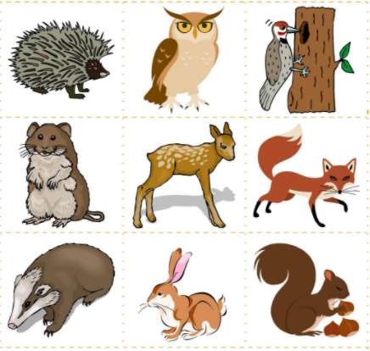  Children to label pictures of animals that you might find in Percy’s park. Remembering to draw a line to the correct animal. | Phonics – split digraphs  https://www.youtube.com/watch?v=L7faYbILI1s  Pupils to practise sounding out and writing split digraph words. | English – Adjectives  Introduce today we are going to be writing some  facts about how the animals look.  Use the image of the animals to model writing a  fact about each animal’s physical appearance in a  sentence.  Children to write a sentence for each animal  describing their physical appearance using an  adjective. eg. A squirrel has a bushy tail. An owl  has big eyes. A rabbit has long ears.
Geography – Ferry Across the Mersey  Children to learn that there is a ferry that goes across the River Mersey between Birkenhead and the Wirral.  https://www.youtube.com/watch?v=C48-UwRWCAw | Music – Understand how sound is represented by symbols  https://classroom.thenational.academy/lessons/understanding-how-sound-is-represented-by-symbols-64w62t | RE – Advent  Understand that Advent is the time when we prepare to celebrate Christmas and the birth of Jesus.  https://www.bbc.co.uk/newsround/42182268#:~:text=Advent%20is%20an%20important%20part,about%20preparing%20for%20Christmas%20Day.&text=Christmas%20celebrates%20Jesus'%20birth%20so,and%20prepare%20for%20those%20celebrations.  Write about what Christians do during this time. eg. Put up a tree, buy presents, watch a nativity, have an advent calendar | Computing – Drawing using shapes  Children to use https://paintz.app/ and explore using the shape tools (circle and square) to create a picture.  Can they make a snail in the style of Henri Matisse using the shape tools? | History – Guy Fawkes  https://www.bbc.co.uk/bitesize/topics/zd8fv9q/articles/zdrrcj6  Who was Guy Fawkes? Children to learn about Guy Fawkes and write sentences about him.  Guy Fakes was born in ____.  Guy Fawkes was from ____.  Guy Fawkes was a _____.s

