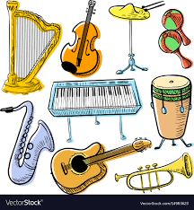

**Year 5 Knowledge Organiser Autumn Term Spanish**

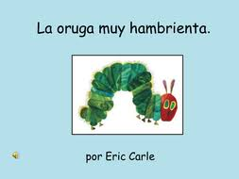

Tengo hambre (I’m hungry)

tengo sed …(I’m thirsty)

¿Qué comes? (What do you eat?)

¿Qué bebes? (What do you drink?)

Como … (I eat)

Bebo … (I drink)

¿Qué comiste/bebiste ayer? (What did you eat/drink yesterday?)

Comí … Bebí (I ate/drank…)

**Important Vocabulary**

La música clásica (classical music) pop/jazz/folklórica (pop/jazz/folk)

Me gusta/no me gusta (I like/do not like)

me encanta (I love)

odio (I hate)

prefiero (I prefer)

During the Autumn Term, Year 5 children will read ‘The Hungry Caterpillar’ in Spanish. They will ask and answer questions about what foods they like, offering their opinions. Later on in the term, they will turn their attention to Spanish music and will talk about different music genres in simple Spanish.