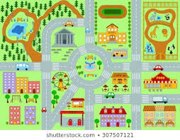

**Did you know?**

Spain is home to numerous impressive churches and cathedrals. There are over 4,000 places of worship in Spain.

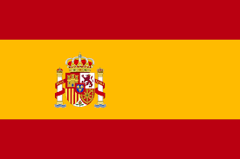

[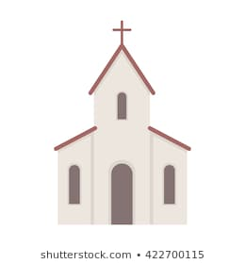](https://www.google.co.uk/url?sa=i&url=https%3A%2F%2Fwww.shutterstock.com%2Fsearch%2Fcartoon%2Bchurch&psig=AOvVaw1Mye2rAqQpVQTUpFxDWb2G&ust=1587544326990000&source=images&cd=vfe&ved=0CAIQjRxqFwoTCLiDr9ON-egCFQAAAAAdAAAAABAD)

la oficina de correos (post office)

el mercado (market)

el parque (park)

el restaurante (restaurant)

la iglesia (church)

la panadería (bakery)

**Important Vocabulary**

¿Dónde está? Está + directions (Where is…?)

¿Qué hay …….? (What is there..?)

a la derecha (on the right)

a la izquierda (on the left)

todo recto (straight on)

¿Dónde está? (Where is it?)

**Year 5 Knowledge Organiser Spring Term Spanish**

During the Spring Term, Year 5 children will read and create simple sentences about places in a town. They will create a dialogue with a partner, focusing on their pronunciation of new Spanish vocabulary. During the second part of the term, they will do some descriptive work, looking at some examples of Spanish art and describing a scene.