travieso (naughty)

feroz (fierce)

rabioso (grumpy)

grande (big)

perfecto (perfect)

alta (tall)

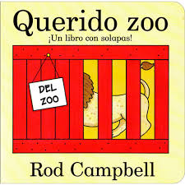

**Did you know?**

Spain is a Mediterranean country with a climate that is cold on the mountain slopes with snow and very hot in the lower regions where the temperature can range from 25 – 30o C.



una serpiente (a snake)

una rana (a frog)

un león (a lion)

un elefante (an elephant)

una jirafa (a giraffe)

un camello (a camel)

un mono (a monkey)

un perro (a dog)

**Year 2 Knowledge Organiser Spring Term**

**Spanish**

During the Spring Term, Year 2 children will listen to some animal descriptions in the story ‘Dear Zoo’. They will start to identify some animal names and be introduced to some adjectives. Later on in the term, they will learn some basic food and drink vocabulary in order to do some simple role play.