Our Lady and St Edwards Knowledge Organiser | Year 4 - Art | Autumn | Volcanic Landscapes
Key Facts about the Artist |  | Key Vocabulary
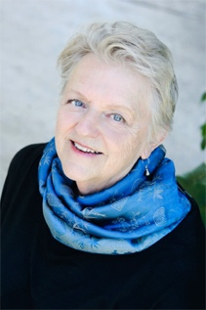  Name: Margret Godfrey  Country of Birth: Oregon, USA  Period: 21st Century  Media: Acrylic Paint  Margaret Godfrey is a symbolic painter. Her pictures incorporate both representational and abstract styles and often include both. She uses watercolour, acrylic, ink, and collage in her creative works.  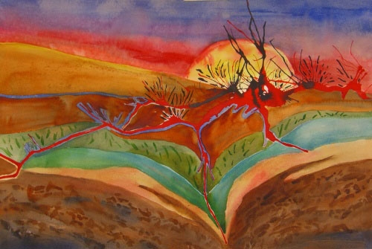  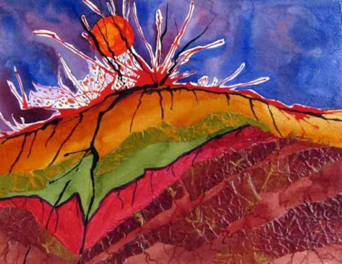 |  | - Volcano – is a mountain that opens downward to a pool of molten rock below the surface of the earth.  - Acrylic Paint –is a fast-drying paint. Acrylic paints can be diluted with water but are water-resistant when dry.  - Strokes – how the paintbrush is used.  - Canvas - a painting made on a piece of cloth stretched on a frame.  - Landscape- one of the principal types of subject in Western art.  - Perspective - a way of showing objects on the flat surface of a picture so that they seem the correct size and distance from one another.  - Visual elements, - e.g. relative size, colour, texture, pattern, detail, form  - Texture - the feel or look of a surface. Painters often use to make their painting interesting.  - Expressionism- art in which the image of reality is distorted in order to express the artist’s ideas
Key Questions |  | Books, internet sites and places to visit
- Why is acrylic paint good to use for paintings on a canvas?  - What are the ‘Visual Elements’?  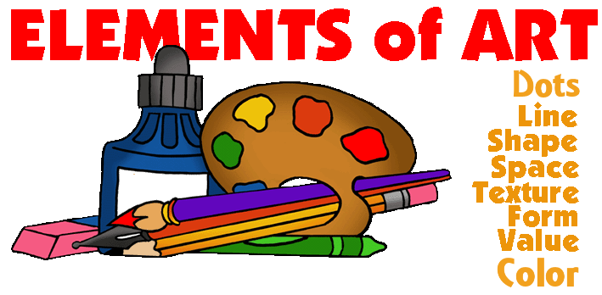  - How can an artist make it look like their painting has texture? |  | https://www.artforkidshub.com/how-to-draw-a-volcano/  https://www.tes.com/teaching-resource/volcano-art-and-dt-6-lesson-unit-of-work-11642123  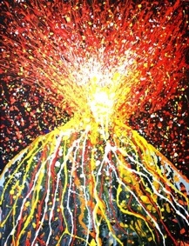  http://margaretgodfreyart.com/about-the-artist/

