Escuchad(listen)

Levantaos (stand up)

Sentaos(sit down)

Silencio(silence)

Mirad (look)

Repetid (repeat)

T – Hola chicos y chicas (Hello girls/boys)

P – Hola Señora…/Señorita…/Señor…

(Hello Mrs…/Miss…/Mr…)

T – Me llamo… ¿Y tú? (My name is…and you?)

P – Me llamo… (My name is…)

[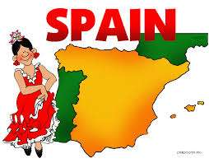](https://www.google.co.uk/imgres?imgurl=https%3A%2F%2Fi.ya-webdesign.com%2Fimages%2Fspain-clipart-subject-spanish.gif&imgrefurl=https%3A%2F%2Fya-webdesign.com%2Fimage%2Fspain-clipart-child-spanish%2F233578.html&tbnid=KQOVOAMR16xphM&vet=12ahUKEwjks6-h0_noAhWZ04UKHVmkDxgQMygUegQIARA6..i&docid=Oikmr7J3M3ycjM&w=777&h=606&q=child%20map%20of%20spain&ved=2ahUKEwjks6-h0_noAhWZ04UKHVmkDxgQMygUegQIARA6)



**F1/F2 Knowledge Organiser Autumn Term**

**Spanish**

Los colores (Colours)

rojo (red)

azul (blue)

verde (green)

amarillo (yellow)

naranja (orange)

rosa (pink)

1. uno 6- seis
2. dos 7- siete
3. tres 8- ocho
4. cuatro 9- nueve
5. cinco 10- diez

During this first term, F1 and F2 children will recognise and begin to use greetings in Spanish. They will learn how to say their name and will become familiar with a simple Spanish poem. Later in the term, they will count up to 10 in Spanish, recognise some colour words and listen and respond to classroom instructions.