Our Lady and St Edwards Knowledge Organiser | Year 1 - Art | Autumn | An Introduction to Colour
The Colour Wheel |  | Key Vocabulary and important Facts
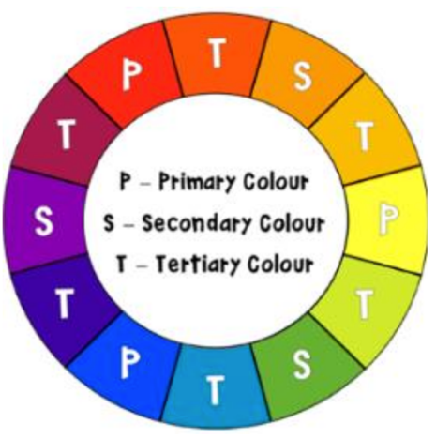  The first colour wheel was created by Sir Isaac Newton in 1666. He discovered that a prism separates light into a spectrum of colours. Colours are represented on a wheel of 12 colours: three primary, three secondary and six tertiary. It also shows warm colours, cool and complimentary colours |  | - Primary colours are colours that cannot be created by mixing other colours. They are red, yellow and blue.  - Secondary colours are colours that can be created by mixing two primary colours. They are green, orange and purple.  - Warm colours upper left of the colour wheel. e.g. red for hot.  - Cool colours lower right of the colour wheel. e.g. blue for cold.  - Complimentary colours are colours that are opposite each other on the colour wheel.  - A tint is the mixture of a colour with white, which increases lightness.  - A shade is the mixture of a colour with black, which reduces lightness.  - A tone is produced either by the mixture of a colour with grey.  - Hue is the term for the pure spectrum of colours - red, orange, yellow, blue, green violet - which appear in the hue-circle or rainbow
Key People, Places and Dates
Art movements associated with emphasis on the use of colour:
- Impressionism - late 19th century Worked in the open air and captured the effects of sunlight by working quickly. This resulted in a greater awareness of light and colour.
- Post- impressionism – late 19th century. The changes in impressionism. A key artist was Vincent Van Gogh.
Key Facts about the Artist |  | Books, internet sites and places to visit
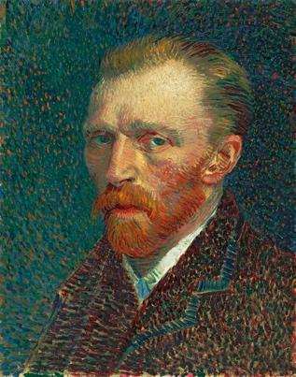  Name: Vincent Van Gogh  Life: 30 March 1853 - 29 July 1890  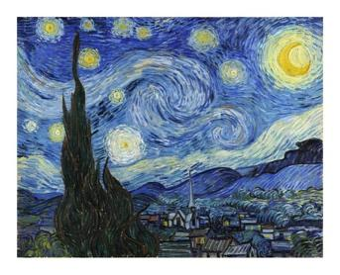  Country of Birth: Zundert, Netherlands  Period: Post Impressionism  Media: Paint |  | - The Day the Crayons Quit by Drew Daywalt, Oliver Jeffers  - Brown Bear, Brown bear, what do you see? Bill Martin Jr.  - The Mixed-Up Chameleon by Eric Carle  - A Color of His Own by Leo Lionni  - Katie and the Starry Night by James Mayhew  - Web sites and books about Van Gogh https://www.bbc.com/bitesize/clips/z4pvcdm https://www.tate.org.uk/kids/make/paint-draw/create-art-vangogh https://www.youtube.com/watch?v=YdRZ2NFSjj8 Van Gogh and the Sunflowers by Laurence Anholt

