**Did you know?**

Spain offers beautiful beaches along the Mediterranean like the Costa Brava and the Costa Dorado. Great cities like Seville and Barcelona attract visitors.



Un helado de chocolate (a chocolate ice-cream)

Un helado de fresa (a strawberry ice-cream)

Un helado de vainilla (a vanilla ice-cream)

Un helado de limón (a lemon ice-cream)

Un helado de turrón (a nougat ice-cream)

Un helado de frambuesa (a raspberry ice-cream)

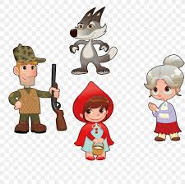

Caperucita roja (Little Red Riding Hood)

la abuela (the grandmother)

el lobo (the wolf)

la cama (the bed)

el cazador (the hunter)

la casa (the house)

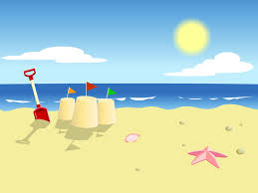

la playa (the beach)

la arena (the sand)

el mar (the sea)

la pelota de playa (the beach ball)

la concha marina (the seashell)

el castillo de arena (the sandcastle)

During the Summer Term, Year 2 children will revise some vocabulary from the first two terms, then will move onto reading ‘Little Red Riding Hood’ in Spanish. They will begin to recognise some of the character names. Later in the term, children will learn some basic ‘beach’ vocabulary and will practise ordering an ice-cream in Spanish.

**Year 2 Knowledge Organiser Summer Term**

**Spanish**