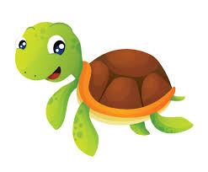

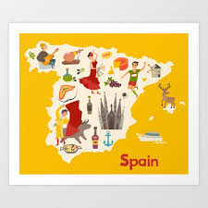

¿Cuántos años tienes? (How old are you?)

Tengo … años (I am … years old)

**F1/F2 Knowledge Organiser Summer Term**

**Spanish**

Ricitos de oro (Goldilocks)

el bosque (the forest)

la casa (the house)

la sopa (the soup)

la silla (the chair)

la cama (the bed)

los osos (the bears)

papá oso (daddy bear)

mamá oso (mummy bear)

bebé oso (baby bear)



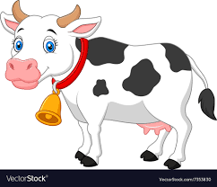

During the Summer Term, F1 and F2 children will learn to say how old they are. They will recognise and repeat vocabulary for farm animals, then read ‘Tilly the Turtle’ in Spanish. Later on in the term, they will read a more familiar story, ‘Goldilocks and the Three Bears’.



Los animales (animals)

la vaca (the cow)

la oveja (the sheep)

el cerdo (the pig)

el pato (the duck)

el caballo (the horse)