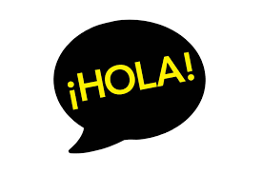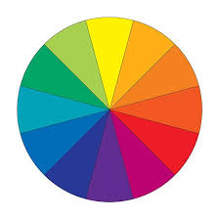

**Did you know?**

Around 406 million people in the world speak Spanish.

There are 21 countries that have Spanish as their official language.

Preguntas: (Questions)

¿Qué color es? (What colour is it?)

¿Cuál es tu color favorito? (What is your favourite colour?)

Me gusta .............. (I like…)

Mi color favorito es ...... (My favourite colour is…)

el negro

el azul

el marrón

el verde

el gris

el morado

el naranja

el rosa

el blanco

el rojo

el amarillo

During the Spring Term, Year 3 children will develop their pronunciation of key Spanish sounds. They will learn new vocabulary linked to ‘Colours’ and ‘Birthdays’ and will learn how to hold a simple conversation with a partner.

¿Cuándo es tu cumpleaños? (When is your birthday?)

Mi cumpleaños es …. (My birthday is…)



**Important Vocabulary**

**Colores (Colours)**

rojo (red)

amarillo (yellow)

verde (green)

azul (blue)

blanco (white)

negro (black)

rosa (pink)

marrón, (brown)

gris (grey)

morado (purple)

naranja (orange)

Year 3 Knowledge Organiser Spring Term Spanish