(la)cabeza (the) head

(los)hombros (the) shoulders

(las)piernas (the) legs

(los)pies (the) feet

(los)ojos (the) eyes

(las)orejas (the) ears

(la)boca (the) mouth

(la)nariz (the) nose



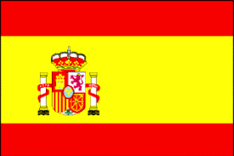

Por favor (please)

Gracias (thank you)

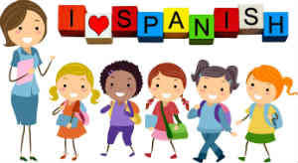

Caminad (walk)

Corred (run)

Saltad (jump)

Nadad (swim)

Aplaudid (applaud)

Bailad (dance)

Por favor (please)

Gracias (thank you)

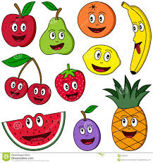

Una fresa (a strawberry)

Un limón (a lemon)

Una manzana (an apple)

Una naranja (an orange)

Una pera (a pear)

Un plátano (a banana)

**F1/F2 Knowledge Organiser Spring Term**

**Spanish**

¿Dónde vives? (Where do you live?)

Vivo en… (I live in…)

During the Spring Term, F1 and F2 children will learn to say where they live and how they are feeling. They will join in classroom songs linked to body parts, ‘Heads, shoulders, knees and toes’. Later on in the term, they will learn some names of fruits, listen and respond to action instructions and say please and thank you.

-To listen and respond to action instructions

-To do a simple role-play using ‘please’ and ‘thank you’