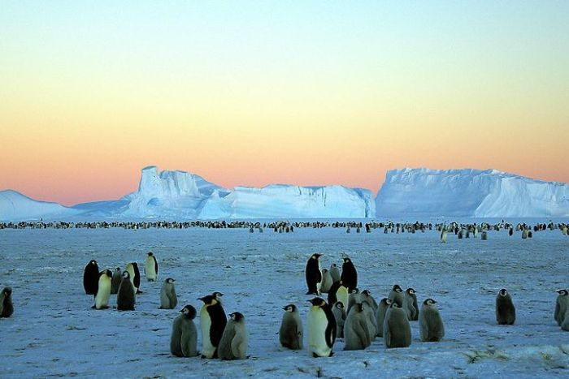

**What can you feel?**

**The bitter air creeps around anything brave enough to survive.**

**What can you smell?**

**What can you see?**

**The tranquil expanse is….**

**Sunlight dancing off the magnificent glaciers.**

**What can you taste?**

**What can you hear?**

**The wind howled and moaned like a ghostly spirit.**