School Spider Parents’ Area
At Our Lady and St Edward’s RC Primary School, we encourage our parents to use our School Spider communication platform. This will allow you to receive important information directly from the school quickly and easily. The school will require your email address to enable you to login.
You will receive your individual logins within the first few weeks of your child starting school.
You will be able to do the following in your parents’ area:
- Book parents’ evenings
- Complete online surveys and forms (these could include school trip/club bookings)
- Smartphone messages (app only)
You will receive an email when there is something you need to complete, if you are logged into the app you will also receive notifications.
Using the app
When you download the app, select our school using the dropdown bar. Once you have done this you can access recent news/gallery/blogs/calendar items we have posted on the website.
To receive information related to your child/children, select Parent Login and enter the username and password we send you. If you have more than one child at the school, click on the child’s name and it will show all other children in the school so you can switch accounts.
You will receive notifications informing you what you need to complete, use the icons on the bottom row to respond.
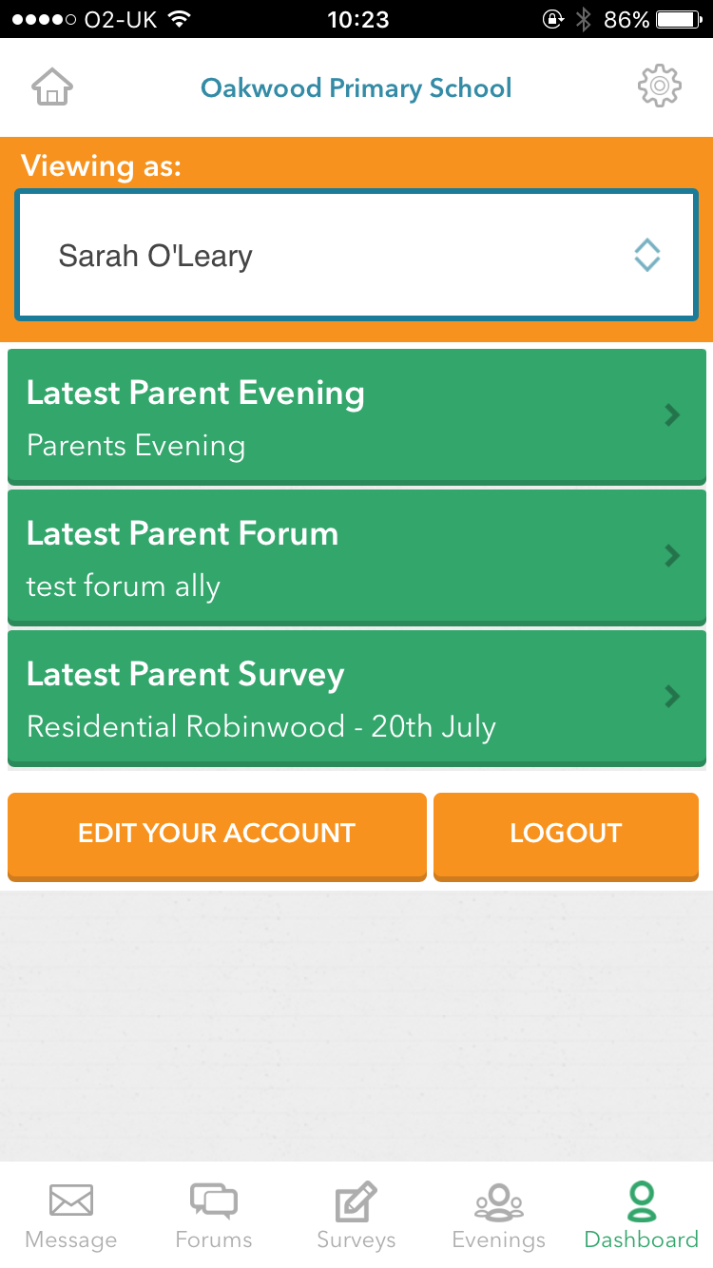
You can watch this YouTube tutorial on the app for more information https://youtu.be/jPmH-CEhLcg
Please ensure once you have logged in you have notifications turned on. We will be using this to replace text messaging so it’s important you do this.

