Charlie and the Chocolate Factory
Who is the new character?
What are they like? (Adjectives)
_____________________________________________________________________________________________________________________________________________________________________________________________________________________________________________________________________________________________________________________________________________________________________________________________________________________________
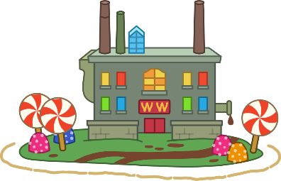
New Character Creator
Name_____________________
Age ______________________
Likes _____________________
Who did they bring to the factory? ____________
How is it resolved?
What happens?
What room do they go in to?

