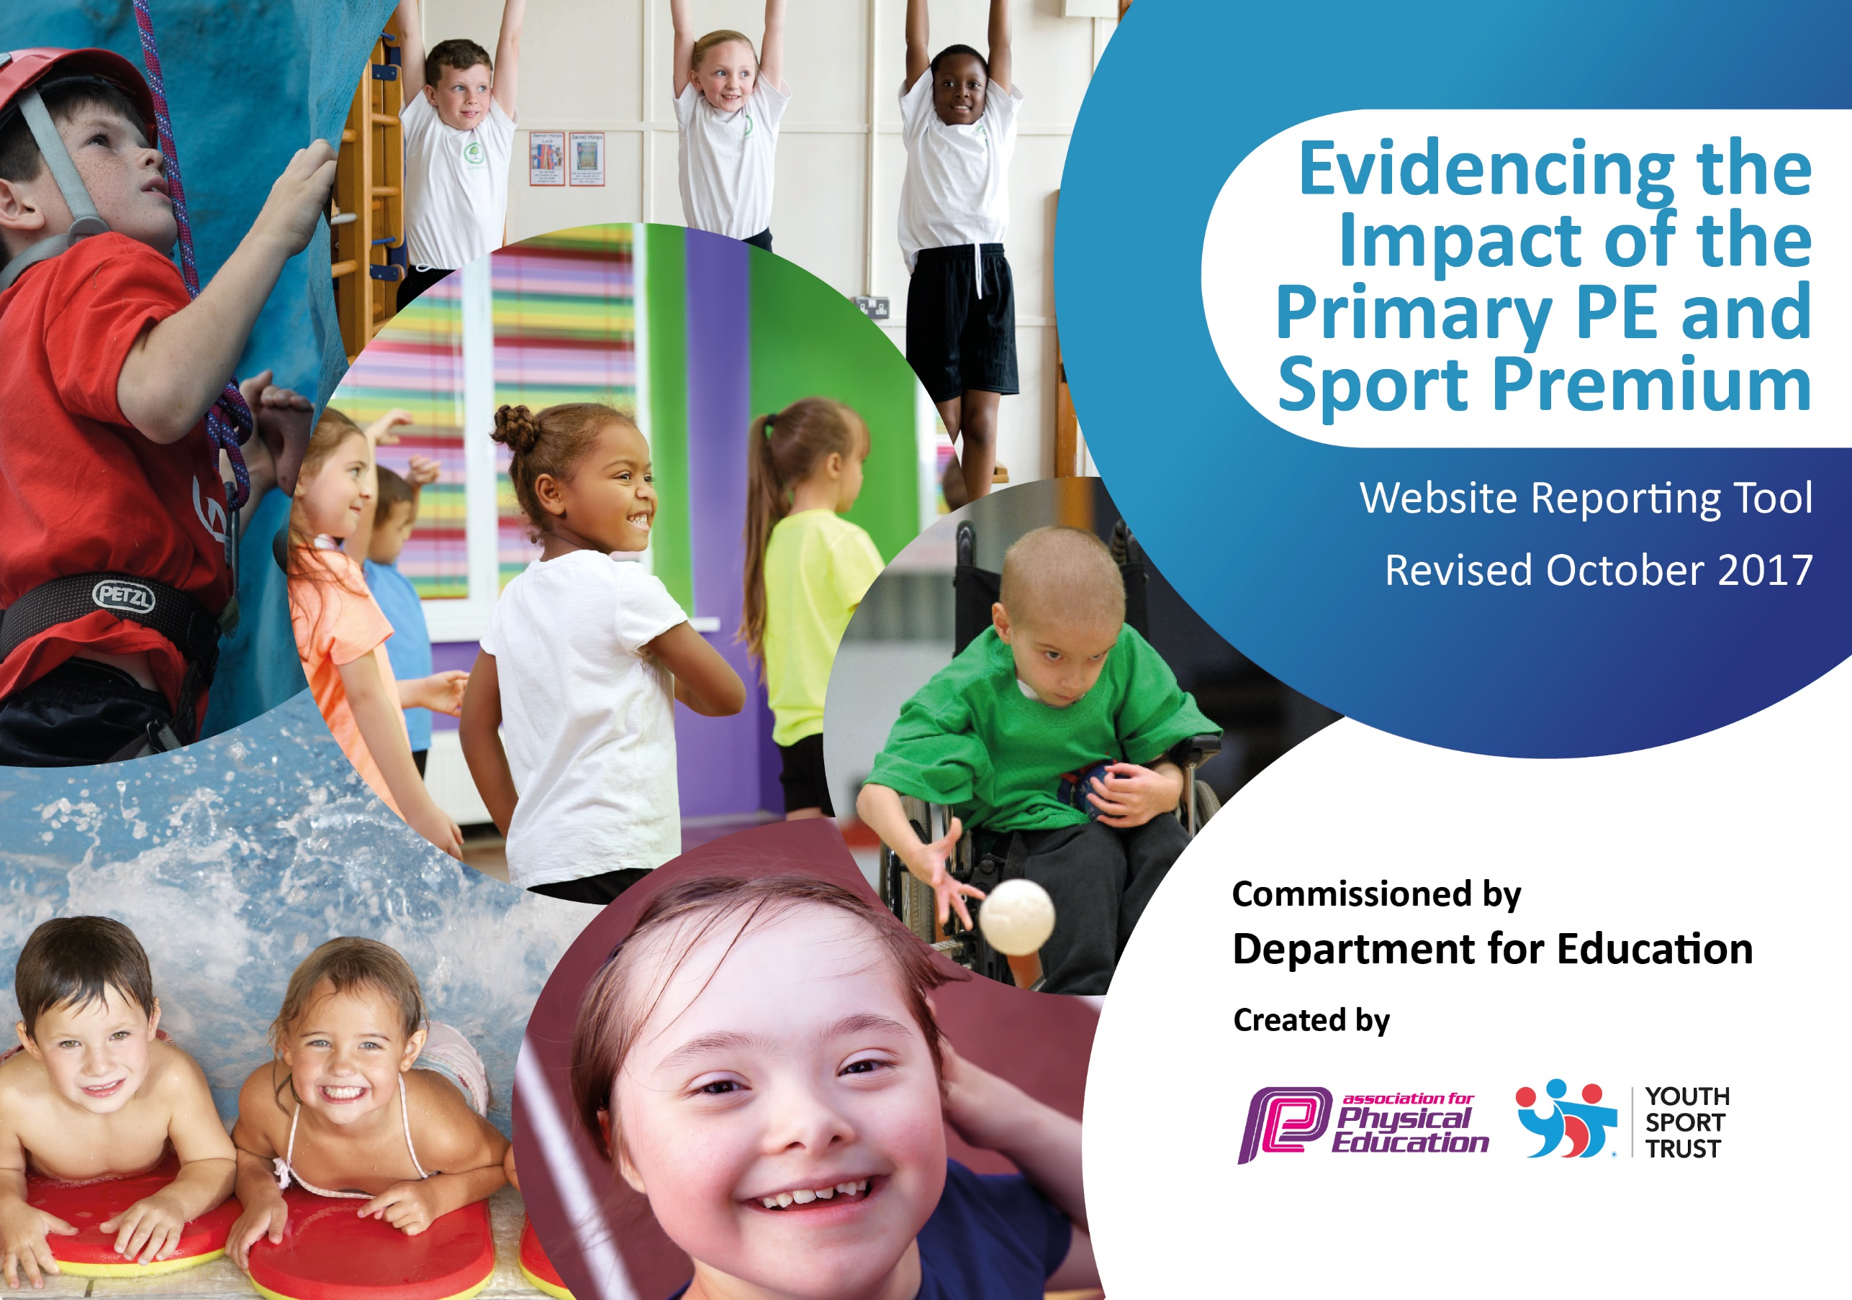

Schools must use the funding to make additional and sustainable improvements to the quality of PE and sport they offer. This means that you should use the Primary PE and Sport Premium to:

- develop or add to the PE and sport activities that your school already offers
- build capacity and capability within the school to ensure that improvements made now will benefit pupils joining the school in future years

Please visit gov.uk for the revised DfE guidance including the 5 key indicators across which schools should demonstrate an improvement. This document will help you to review your provision and to report your spend. DfE encourages schools to use this template as an effective way of meeting the reporting requirements of the Primary PE and Sport Premium.

We recommend you start by reflecting on the impact of current provision and reviewing the previous spend.
Under the Ofsted Schools Inspection Framework, inspectors will assess how effectively leaders use
the Primary PE and Sport Premium and measure its impact on outcomes for pupils, and how effectively governors hold them to account
for this.

Schools are required to publish details of how they spend this funding as well as on the impact it has on pupils’ PE
and sport participation and attainment.
We recommend regularly updating the table and
publishing it on your website as evidence
of your ongoing review into how you are using the money
to secure maximum, sustainable impact. To see an example of how to complete the table please click HERE.

Support for review and reflection - considering the 5 key indicators from DfE, what development needs are a priority for your setting and your students now and why? Use the space below to reflect on previous spend, identify current need and priorities for the future.

Key achievements to date: | Areas for further improvement and baseline evidence of need:
-Increased participation in playtime and lunchtime activities through the additional provision provided and through the use of equipment.  -Although still not as high as we would like to target, giving non-National Curriculum swimmers additional swimming time has begun to improve this and we shall be looking to continue this.  -Large numbers of children participated in competitive competition. | -Year 6 National Curriculum level swimmers was 38% for the 2017-2018 academic year. We shall be looking to improve this through extra swimming funded through PE premium and also in how we spend this. We shall be looking to give some of our non-National Curriculum level swimmers an additional weeks swimming to make targets more achievable.  -We would like to focus on improving resilience and positive mental health through Physical Education. This will be evidenced through a noted improvement to children’s resilience, initially within PE and then through seeing and impact in their wider school life.  -Continue to encourage increased participation in physical activity, through structured playtime and lunchtime activities. This will be evidenced through an increased interest from the children to participate during these. Including children who have previously been disengaged.

Swimming

Meeting national curriculum requirements for swimming and water safety | Please complete all of the below:
What percentage of your Year 6 pupils could swim competently, confidently and proficiently over a distance of at least 25 metres when they left your primary school at the end of last academic year? | 60 %
What percentage of your Year 6 pupils could use a range of strokes effectively [for example, front crawl, backstroke and breaststroke] when they left your primary school at the end of last academic year? | 62 %
What percentage of your Year 6 pupils could perform safe self-rescue in different water-based situations when they left your primary school at the end of last academic year? | 60 %
Schools can choose to use the Primary PE and Sport Premium to provide additional provision for swimming but this must be for activity over and above the national curriculum requirements. Have you used it in this way? | Yes

Action Plan and Budget Tracking
Capture your intended annual spend against the 5 key indicators. Clarify the success criteria and evidence of impact that you intend to measure to evaluate for students today and for the future.

Academic Year: 2018/19 | Total fund allocated: £19,539 Spent-16,506.70 | Date Updated:19/07/2019
Key indicator 1: The engagement of all pupils in regular physical activity – Chief Medical Officer guidelines recommend that primary school children undertake at least 30 minutes of physical activity a day in school |  |  |  |  | Percentage of total allocation:
 |  |  |  |  | %
School focus with clarity on intended impact on pupils: | Actions to achieve: | Funding allocated: | Evidence and impact: |  | Sustainability and suggested next steps:
Extra Lunchtime Provision | Extra staff and provision leading and organising physical activity opportunities at lunch time. Pupils comment on increased and improved opportunities. PE staff at lunchtimes and after school. | £5000 | Staff leading activities alongside Play Leaders. Wider range of activities and pupils comment on how the playground is more fun.  Children have reported increased enjoyment of lunchtime activities. They also commented on how they feel like they have increased their physical activity. Some also said they were now doing similar activities at home. |  | 25.5%  Extra lunch staff should continue to provide the extra opportunities for activities. Consider making the programme a little more specific in terms of the activities.
Improvement of playground facilities | Increased use of the equipment, leading to children becoming more engaged with participation in physical activity. | £2000 | Staff leading activities alongside Play Leaders. Wider range of activities and pupils comment on how the playground is more fun.  This has allowed staff to provide a wider range of activities, keeping the children engaged and interested. |  | 10%  Equipment should continue to be used. The next step is to vary the activities the equipment is used for.
Improve children’s resilience and encourage positive mental health through Physical Education. | Children will take part in the PERSONAL Best Programme. | Edsential Standard  Package (£5100) | Children showing resilience within physical activity. Wider impact would also see this impacting on their resilience in other areas.  Children commented on how they enjoyed the challenge of the programme and how they grew in confidence in the later part. |  | 26%  This programme has run for several years with good success. The next step is to to target other areas and buy into expert programmes to deliver these and work with staff.
Key indicator 2: The profile of PE and sport being raised across the school as a tool for whole school improvement |  |  |  | Percentage of total allocation:
 |  |  |  | %
School focus with clarity on intended impact on pupils: | Actions to achieve: | Funding allocated: | Evidence and impact: | Sustainability and suggested next steps:
New sports equipment, to interest and engage children in new and existing sports. | Children are inspired by new and engaging activities. Heightening their interest in sports and keeping healthy. This may also include competing in new sports against other schools. | £606.70 | Increase and inspire an interest in PE among children have previously been less engaged with physical activity.  Children felt that the new equipment allowed all of them to be engaged and involved. Some also asked about us buying equipment for other possible sports in the future. | 3%  To spend money on a range of different equipment, to increase the range of activities open to the children.

Key indicator 3: Increased confidence, knowledge and skills of all staff in teaching PE and sport |  |  |  | Percentage of total allocation:
 |  |  |  | %
School focus with clarity on intended  impact on pupils: | Actions to achieve: | Funding  allocated: | Evidence and impact: | Sustainability and suggested  next steps:
PE Curriculum CPD delivered by PE Specialists to support school staff | Staff comment on improved confidence and competence to teach in targeted areas of PE Curriculum | Edsential Standard Package | With a new sports assistant commencing employment with us, in order to support our sports coach, we used CPD to support how best to deploy sports staff. This had a positive impact in that it gave the new assistant more confidence and also ensured the money spent on this is being utilized.  Specialised dance CPD was also used, again increasing confidence of staff. By looking at a different form of dance it also had a positive impact in that boys also commented on how they enjoyed the dance sessions, which was an area we had been targeting.  Outdoor learning, linked to English was also successful. Inspiring some superb writing from Year 6. It also provided the staff with ideas which they will use in future. | Part of 26%  We shall continue to use CPD through Edsential with teaching staff, as next year they shall be delivering their own PE.
Key indicator 4: Broader experience of a range of sports and activities offered to all pupils |  |  |  | Percentage of total allocation:
 |  |  |  | %
School focus with clarity on intended  impact on pupils: | Actions to achieve: | Funding  allocated: | Evidence and impact: | Sustainability and suggested  next steps:
Extra Swimming for non-swimmers | To allow the opportunity for some of the children still not meeting National Curriculum standards, through the regular lessons provided by school, to engage further though swimming and develop their skills | £2800 | Increase in the number of pupils reaching National Curriculum Level in swimming. Children’s comments on their enjoyment of swimming.  Increased from 38% last year to 60% this year. | 14%  This has had a fantastic impact on swimming results and we shall continue to use some money towards this. We shall also look to train more staff as instructors to ensure groups are smaller and children get more swimming time made available to them.
Key indicator 5: Increased participation in competitive sport |  |  |  | Percentage of total allocation:
 |  |  |  | %
School focus with clarity on intended  impact on pupils: | Actions to achieve: | Funding  allocated: | Evidence and impact: | Sustainability and suggested  next steps:
Contribution towards cost of school minibus | 25% of KS2 children taking part in an inter or level 2 competition. Increased access to local sports facilities to enhance the curriculum and extra curricular provision. | £1000 | 20% of pupils have taken part in at least 1 competition throughout the school year.10% of pupils have regularly (at least x 2 per term) represented the school in level 2 competitions.  This allowed children to compete against other schools. Due to staff changes, money has been invested to train more staff so that they are able to drive the minibus. | 5%  Money is being invested to have more staff trained to drive the minibus. We shall also be entering the sports festivals for Foundation and KS1, in order to target the amount of opportunities they have to compete in competitions.

