INFORMATION SHARING:

The General Data Protection Regulation (GDPR) and the Data Protection Act 2018 introduce new elements to data protection management, superseding the Data Protection Act 1998. It places a greater significance on organisations being transparent and accountable in relation to their use of data. All organisations handling personal data need to have comprehensive and proportionate arrangements for collecting, storing, and sharing information.

The seven golden rules to sharing information:

- Remember that the General Data Protection Regulation (GDPR), Data Protection Act 2018 and human rights law are not barriers to justified information sharing; they provide a framework to ensure that personal information about living individuals is shared appropriately.

- Be open and honest with the individual (and/or their family where appropriate) from the outset about why, what, how and with whom information will, or could be shared, and seek their agreement, unless it is unsafe or inappropriate to do so.

- Seek advice from other practitioners, or your information governance leads, if you are in any doubt about sharing the information concerned, without disclosing the identity of the individual where possible.

- Where possible, share information with consent, and where possible, respect the wishes of those who do not consent to having their information shared. Under the GDPR and Data Protection Act 2018 you may share information without consent if, in your judgement, there is a lawful basis to do so, such as where safety may be at risk. Base your judgement on the facts of the case and be clear of the basis upon which you are doing so. Where you do not have consent, be mindful that an individual might not expect information to be shared.

- Consider safety and well-being: base your information sharing decisions on considerations of the safety and well-being of the individual and others who may be affected by their actions.

- Necessary, proportionate, relevant, adequate, accurate, timely and secure: ensure that the information you share is necessary for the purpose for which you are sharing it, is shared only with those individuals who need to have it, is accurate and up-to-date, is shared in a timely fashion, and is shared securely (e.g. secure e-mails, password protect and see full document for more examples).

- Keep a record of your decision and the reasons for it – whether it is to share information or not. If you decide to share, then record what you have shared, with whom and for what purpose.

Sharing of information between practitioners and organisations is essential for effective identification, assessment, risk management and service provision. Fears about sharing information cannot be allowed to stand in the way of the need to safeguard and promote the welfare of children and young people at risk of abuse or neglect.
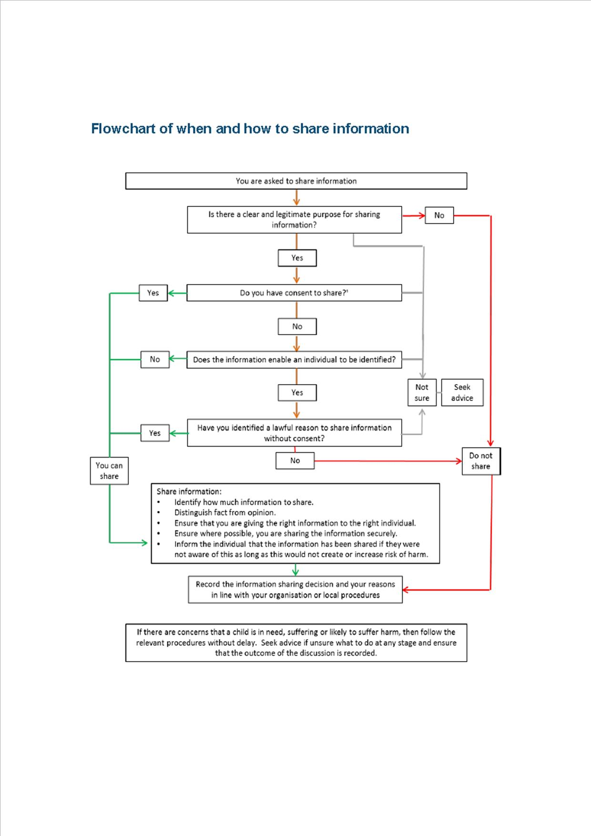

Sourced from: Information sharing - Advice for practitioners, providing safeguarding services to children, young people, parents and carers (July 2018) HMG:
To access the full document: https://assets.publishing.service.gov.uk/government/uploads/system/uploads/attachment_data/file/721581/Information_sharing_advice_practitioners_safeguarding_services.pdf

